# CS 255 System Design Document Template

## UML Diagrams

## UML Use Case Diagram

"The Use Case Diagram visually captures the interactions between all users of the DriverPass system and the services provided, ensuring a user centered design approach."

### UML Activity Diagrams

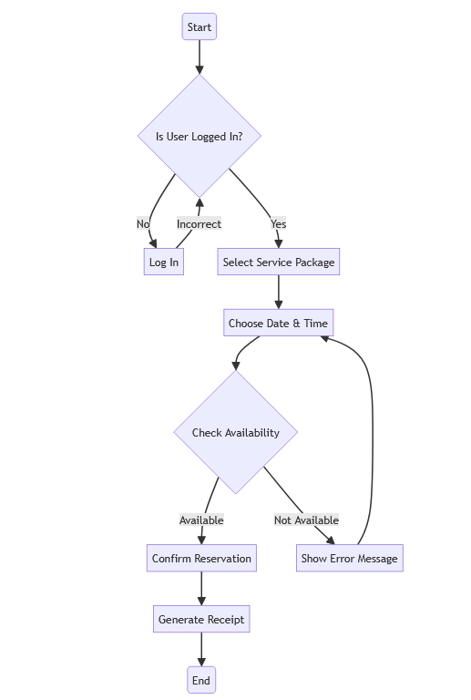

"The Activity Diagrams detail the step-by-step workflow for booking a driving lesson and registering a new user, designed for clarity and ease of use."

### UML Sequence Diagram

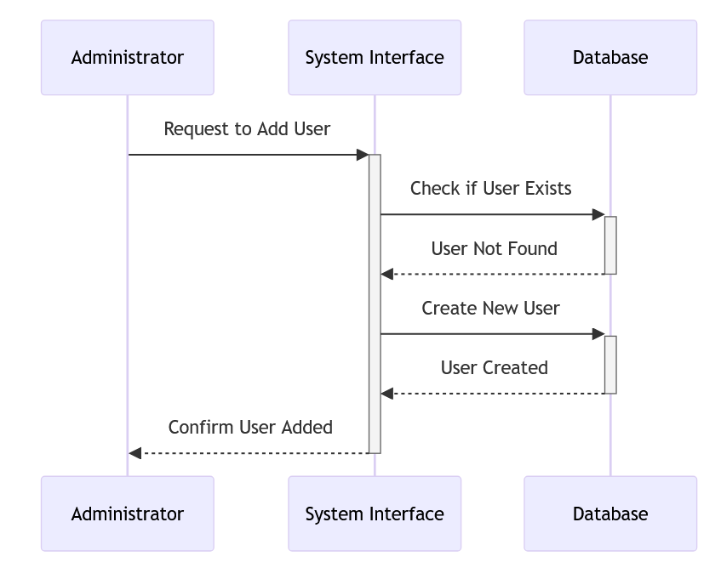

"The Sequence Diagram displays the interaction sequence for managing user accounts, highlighting the system's efficiency and responsiveness to user actions."

### UML Class Diagram

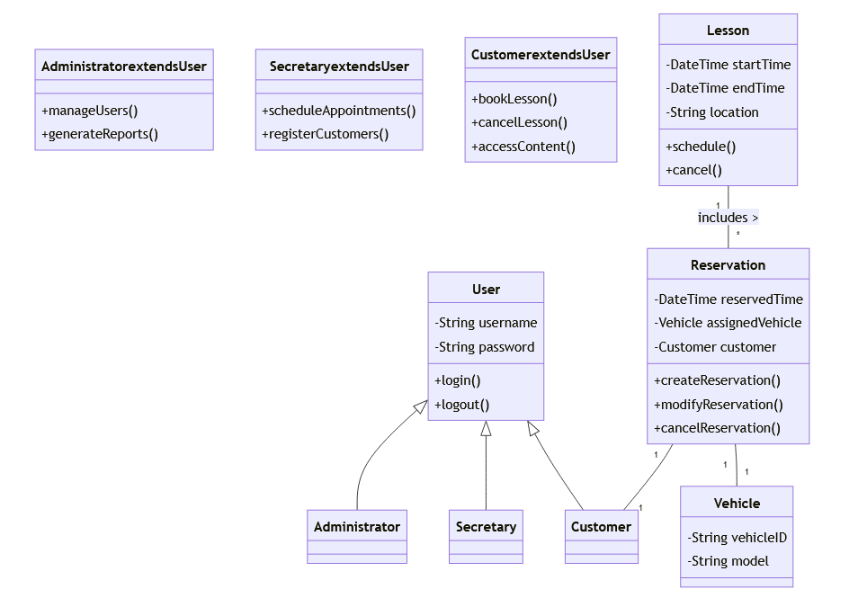

"The Class Diagram outlines the structure of the system with classes such as User, Lesson, and Reservation, reflecting the robust and scalable design of the DriverPass platform."

## Technical Requirements

"The DriverPass system is designed to be hosted on a scalable cloud infrastructure, ensuring reliable and consistent performance across all user interactions. The front end will be accessible through standard web browsers, allowing cross-platform compatibility for both desktop and mobile devices. On the backend, a secure, similar database will manage all data transactions, while the server-side logic will be handled by a framework capable of supporting high concurrency and providing real-time feedback to the users. Security measures, including industry-standard encryption and authentication protocols, will keep user data safe."